**Problem 1:**

Bayes Net:

Denote note N being fired: N =1, N = 0 otherwise

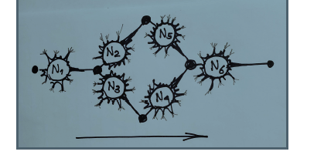

Given N1 is stimulated:

* P(N1 = 1) = 0.9

Probability of a node is being fired given its parent:

* P(Ni = 1|Ni-1 = 1) = 0.9
* P(Ni =1|Ni-1 =0) = 0.05
* (i,i-1) in (2,5), (3,4)

Probability of node N6 is being fired given its parents:

* P(N6 = 1|N5 = 1, N4 = 1) = 0.9
* P(N6 = 1|N5 = 0, N4 = 1) = 0.9
* P(N6 = 1|N5 = 1, N4 = 0) = 0.9
* P(N6 = 1|N5 = 0, N4 = 0) = 0.05

Using variable elimination:

1. Probability that N6 will be fired is 0.900453
2. Probability that N6 will be fire is N4 did not fire is 0.9047627
3. Probability that N5 received stimulus if N6 did not fire is 0.904794

**Problem 2:**

$$P\left(X_{i} | λ\right) \sim Ga\left(r, λ\right)$$

$$π\left(λ\right)\sim Ga(α, β)$$

$f(λ, X1, X2, …X23$) = $\frac{\prod{{Xi}^{r-1}}}{{Γ(r)}^{23}} \frac{{ β}^{α}}{Γ(α)} λ^{23r+ α-1}e^{-λ ( β+ Σx_{i})}$

Therefore,

$λ|(X1, X2, …X23) \sim Ga(α+ nr, β+ Σx_{i})$

Bayesian estimator of $λ$: $λ=\frac{\left(α+ nr\right)}{β+ Σx_{i}}$ = 0.5551

The 95% equitailed credible set for $λ$ is [0.44908894, 0.67212117]

Posterior (H: $λ<0.5 \left|X\right)=0.16688$

**Problem 3: Gibbs Sampler and Mating Call**

**Denote:**

For Y1 we have:

$$π\left(µ_{1}, τ_{1}, Y_{1}\right)=f\left(Y1 | µ_{1},τ_{1}\right)π\left(τ_{1}\right)π\left(µ_{1}\right)∝\exp{\{-0.5 (19.5283}τ_{1}-\left(55.9+1.2\right)τ_{1} µ_{1}+\left(43τ_{1}+1\right){µ_{1}}^{2}+0.36)\}$$

**Therefore,**

$$µ_{1}|Y1, τ_{1} \sim N(\frac{27.98 τ_{1}+0.6}{43τ_{1}+1}, \frac{1}{43τ_{1}+1})$$

Similarly,

$$τ_{1}|µ_{1}, Y1 \sim Ga(41.5, 0.5+0.5\sum_{i=1}^{43}{(\overline{Y1}}-µ_{1})^2)$$

$$µ_{2}|Y2, τ_{2} \sim N(\frac{6.48 τ_{2}+0.6}{12τ_{2}+1}, \frac{1}{12τ_{1}+1})$$

$$τ_{2}|µ_{2}, Y2 \sim Ga\left(26, 0.5+0.5\sum_{i=1}^{12}{(\overline{Y2}}-µ_{2})^2\right)$$

1. After 11000 simulations, 95% credible set for $µ_{1}-µ_{2} is \left[0.09609863, 0.108000456\right]$

This set does not contain 0, therefore we can reject the null hypothesis

H0: $µ_{1}=µ_{2}$

Based on this analysis, the length of the call is a discriminatory characteristic since Hyla chrysoscelis exhibit longer length of the call than Hyla versicolor.

**Code for Problem 1:**

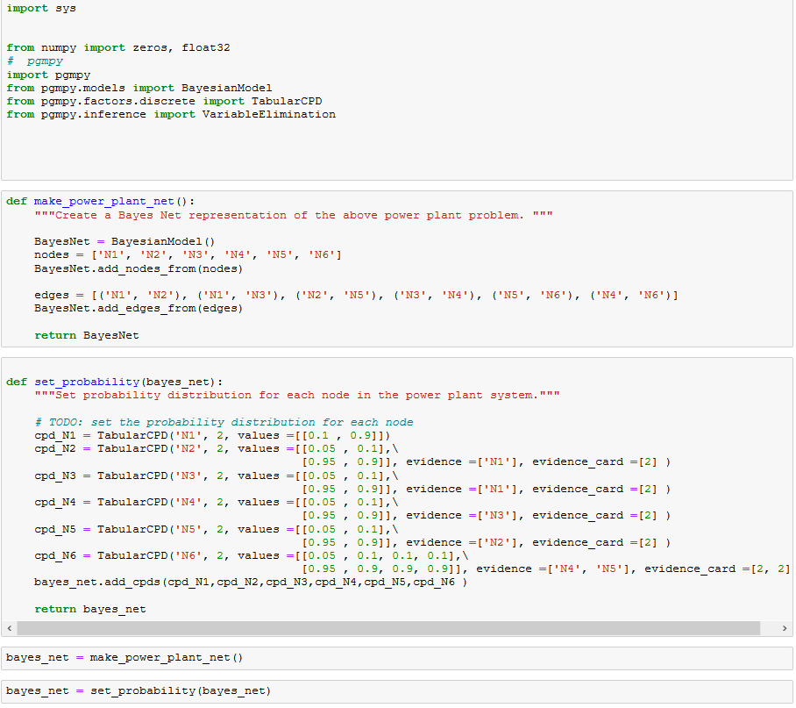

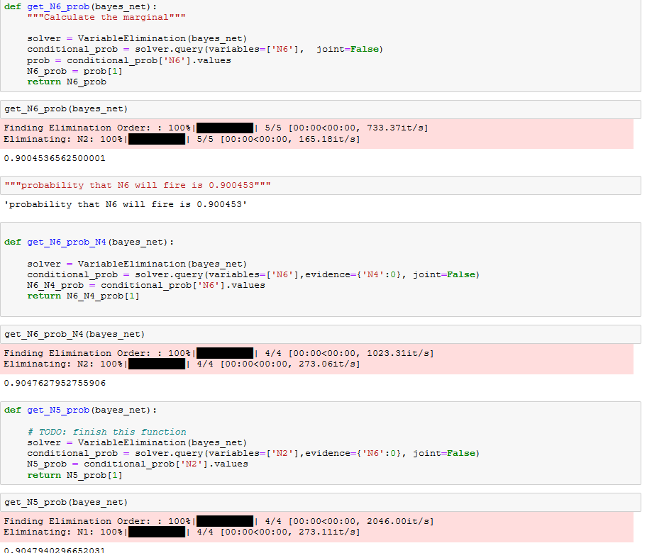

**Code for Problem 2:**

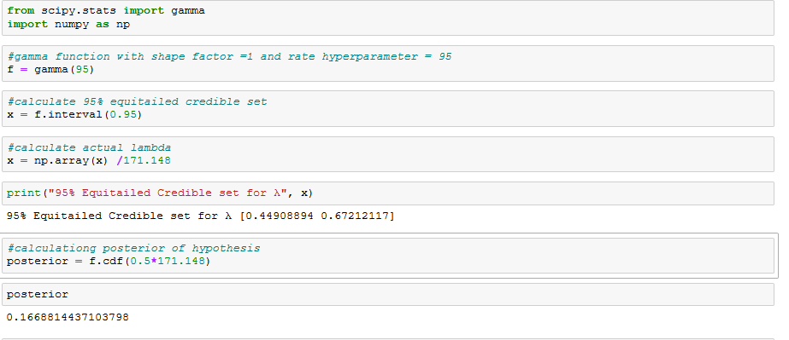

**Code for Problem 3**

